**DATING APP MANAGEMENT SYSTEM**

**Milestone: Implementation In NoSQL**

Group 20

Bhavya Pandey

Shaun Kirthan

617-606-1918 (Bhavya)

857-701-6581(Shaun)

pandey.bh@northeastern.edu

[lnu.shau@northeastern.edu](mailto:lnu.shau@northeastern.edu)

**Percentage of Effort Contributed by Bhavya Pandey: 50%**

**Percentage of Effort Contributed by Shaun Kirthan: 50%**

**Signature of Student 1:** Bhavya Pandey

**Signature of Student 2:** Shaun Kirthan

**Submission Date:** 03 December 2023

1. Retrieve User Information

db.User.findOne({ User_id: 1 });

1. Retrieve all events

db.Events.find()

1. Calculate Average Rating for Events

db.Reviews.aggregate([

{

$group: {

_id: "$Event_id",

averageRating: { $avg: "$Rating" }

}

}

]);

1. Find users who have liked others along with their like details

db.User.aggregate([

{

$lookup: {

from: "Likes",

localField: "User_id",

foreignField: "liked_by",

as: "likesDetails"

}

}

]).pretty();

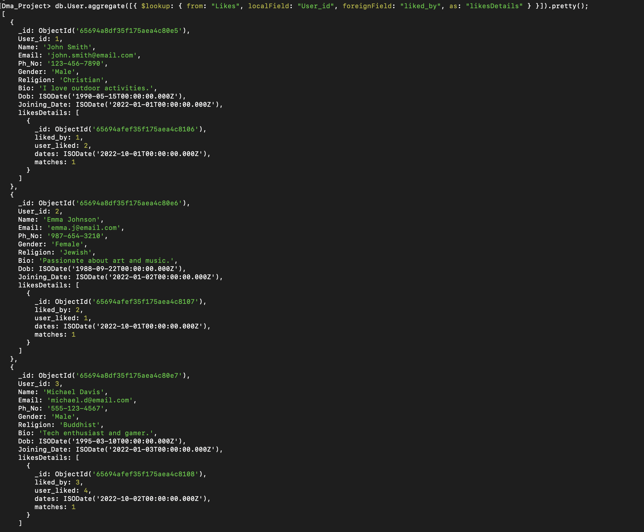

1. Map-Reduce query to find the total number of events organized by each user:

db.Events.mapReduce(

function () {

emit(this.Organizer_id, 1);

},

function (key, values) {

return Array.sum(values);

},

{ out: "userEventCount" }

);

db.userEventCount.find();

